ECS Fargate NGINX Deployment with ALB and EFS Documentation
Table of Contents
ECS Fargate NGINX Deployment with ALB and EFS Documentation 1
Prerequisites 2
Objective 2
High Level Architecture 3
Project Structure 4
Module Explanation 4
1. VPC Module 5
Purpose 5
Key Resources Provisioned 5
Outputs 5
2. Security Module 5
Purpose 5
Key Security Groups 5
Notes 5
3. EFS Module 6
Purpose 6
Key Resources 6
Why EFS 6
4. ECR Module 6
Purpose 6
Key Resources 6
5. ALB Module 6
Purpose 6
Key Resources 6
Why ALB 7
6. ECS Module 7
Key Components 7
ECS Cluster 7
Task Definition (taskdef.tf) 7
IAM Roles Created 7
ECS Service 7
Backend Definition (Root Files) 7
provider.tf 7
backend.tf 8
variables.tf and outputs.tf 8
terraform.tfvars 8
Summary 8
Terraform Deployment Commands 8
Initialize providers and modules 8
Format code (optional but recommended) 8
Validate configuration 8
View changes before applying 9
Deploy infrastructure 9
Custom Docker Image Build and Push 9
Validation and Testing 10
1. Validate Infrastructure from the AWS Console 10
2. Validate Application via Browser 11
11
3. Cleanup 11
Troubleshooting 11
Issue 1 : ALB Shows Service Unhealthy 11
Issue 2: 403 Forbidden Error 12
Issue 3 : Using the same CIDR range as other users 12
Issue 4 : ECS service shows old/incorrect container image (e.g., WordPress instead of custom NGINX) 12
Conclusion 13

Prerequisites
Before starting, ensure the following:
- AWS account with appropriate permissions (EC2, ECS, IAM, EFS, ALB, VPC)
- Terraform installed (v1.x or later)
- AWS CLI configured locally (aws configure)
- An S3 bucket created beforehand for Terraform remote backend
- Docker installed for building and pushing custom container images
- Basic understanding of VPC networking and Terraform modular architecture
This deployment is fully automated using Terraform in a multi-module structure.

Objective
The goal of this project is to deploy a secure and scalable NGINX application on AWS ECS Fargate using:
- ECS Fargate for serverless container hosting
- Application Load Balancer for external access and traffic distribution
- Amazon EFS for persistent storage across tasks
- A custom Docker image hosted on ECR
- A fully managed and tagged VPC networking layer
- IAM roles and permissions for ECS tasks
- Modern Terraform modular architecture

High Level Architecture
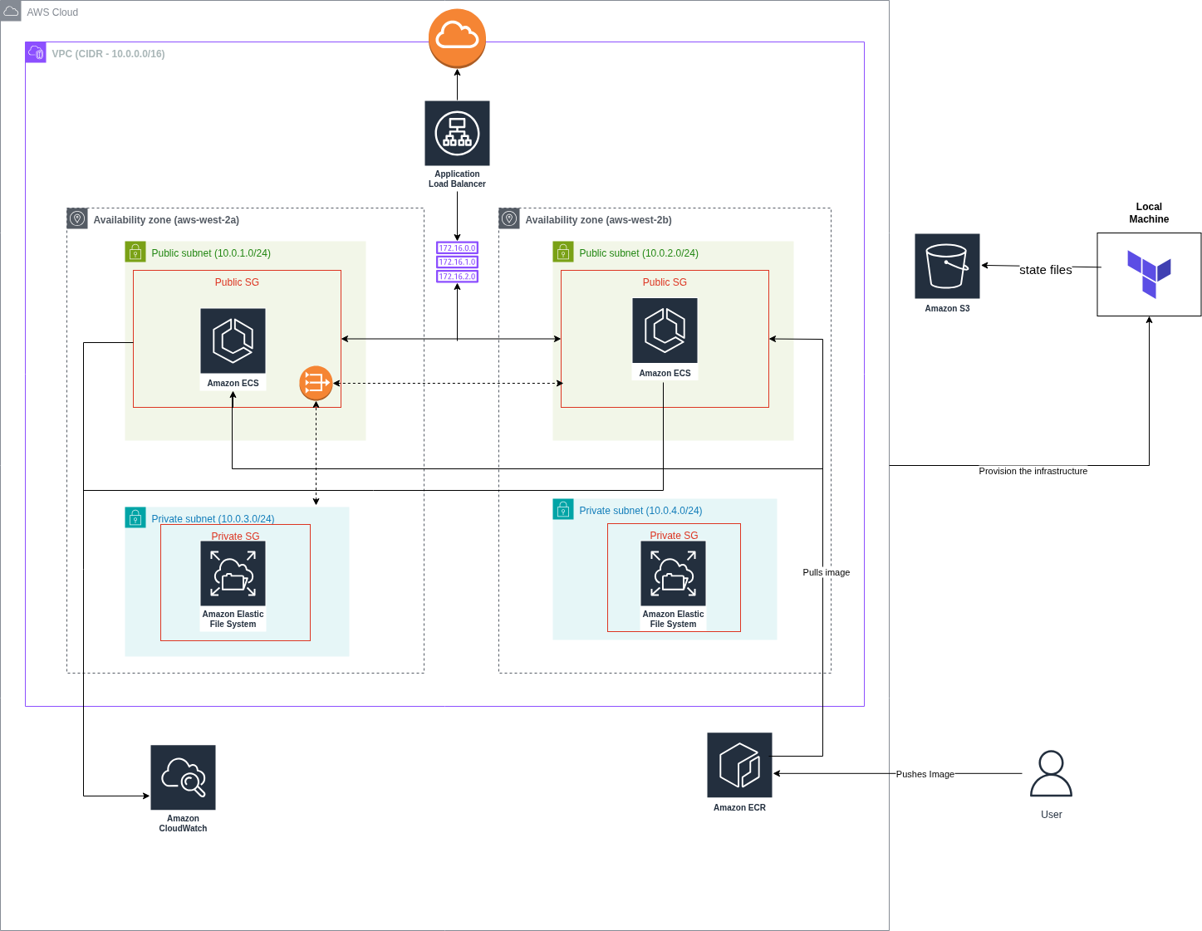

Project Structure
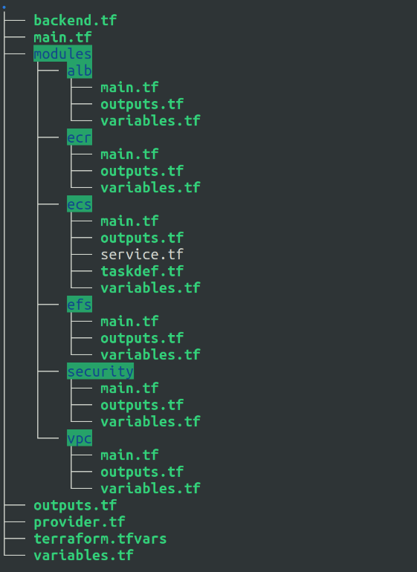
Each module in this structure is independent and reusable.

Module Explanation
Below is a functional overview of each module and the infrastructure it provisions.

1. VPC Module

Purpose
Creates a network environment for the application following AWS best practices.

Key Resources Provisioned
- VPC
Defines the private network (10.0.0.0/16) hosting the environment.
- Public Subnets (2)
Used for the Application Load Balancer.
- Private Subnets (2)
Used by ECS Fargate tasks and EFS mount targets.
- Internet Gateway
Enables public outbound internet access for ALB.
- NAT Gateway
Allows private subnets to reach the internet securely.
- Route Tables and associations
Proper routing for public and private traffic flow.

Outputs
Returns the VPC ID and the subnet IDs required by other modules.

2. Security Module

Purpose
Defines all security groups required for ALB, ECS, and EFS.

Key Security Groups
- ALB Security Group
Allows inbound HTTP (80) from the internet.
- ECS Task Security Group
Allows incoming traffic only from ALB security group.
- EFS Security Group
Allows NFS (port 2049) access only from ECS tasks.

Notes
No wide-open inbound traffic is allowed in private services.

3. EFS Module

Purpose
Provides persistent storage that remains available even if ECS tasks stop or restart.

Key Resources
- EFS File System
Primary shared storage.
- EFS Mount Targets (one per private subnet)
Ensures ECS tasks can mount the file system from within the VPC.

Why EFS
Containers in Fargate are ephemeral. EFS ensures files persist across redeployments and multiple tasks.

4. ECR Module

Purpose
Creates a private Docker image repository for hosting the custom NGINX image.

Key Resources
- ECR Repository
The location where Docker images are pushed and versioned.
Developers build the image locally and push it using:
- docker build
- docker tag
- docker push
ECS tasks then pull the image directly from ECR.

5. ALB Module

Purpose
Provides external access to the NGINX service and routes traffic to ECS tasks.

Key Resources
- Application Load Balancer
Public-facing entry point to the application.
- Listeners (HTTP 80)
Accepts external traffic.
- Target Group
Attached to ECS service. Receives traffic and load balances across tasks.

Why ALB
Supports health checks, automatic failover, and multi-AZ resilience.

6. ECS Module
This is the core execution environment.

Key Components

ECS Cluster
Logical container runtime environment where tasks run.

Task Definition (taskdef.tf)
Defines how the container runs, including:
- Docker image from ECR
- Container port mapping (80 → host)
- CPU and memory requirements
- EFS volume mount

IAM Roles Created
- Task Execution Role
Allows ECS to:
  - Pull images from ECR
  - Write logs to CloudWatch
- Task Role
Used by the application if it needs AWS SDK access later.

ECS Service
Deploys and maintains the running containers by:
- Ensuring the required number of tasks are always running
- Registering tasks in ALB target groups
- Redeploying automatically if containers exit

Backend Definition (Root Files)

provider.tf
Configures AWS provider and region.

backend.tf
Stores Terraform state remotely in an S3 bucket for reliability.

variables.tf and outputs.tf
Declares input and output parameters used throughout modules.

terraform.tfvars
Used only for user-driven values such as:
- region
- CIDRs
- RDS credentials
- container image name
- environment tag

Summary
At this point, the Terraform configuration defines:
- Fully tagged and isolated VPC networking
- Secure routing through IGW and NAT gateway
- Public ALB distributing traffic to private ECS tasks
- EFS shared storage mounted by containers
- ECR repository hosting custom Docker images
- ECS services managed with IAM roles for deployment and logging
This completes the infrastructure and configuration documentation.

Terraform Deployment Commands

Initialize providers and modules
terraform init

Format code (optional but recommended)
terraform fmt

Validate configuration
terraform validate

View changes before applying
terraform plan

Deploy infrastructure
terraform apply

Custom Docker Image Build and Push
The deployment expects a custom NGINX image located in ECR. Build and push using standard Docker and AWS CLI commands.
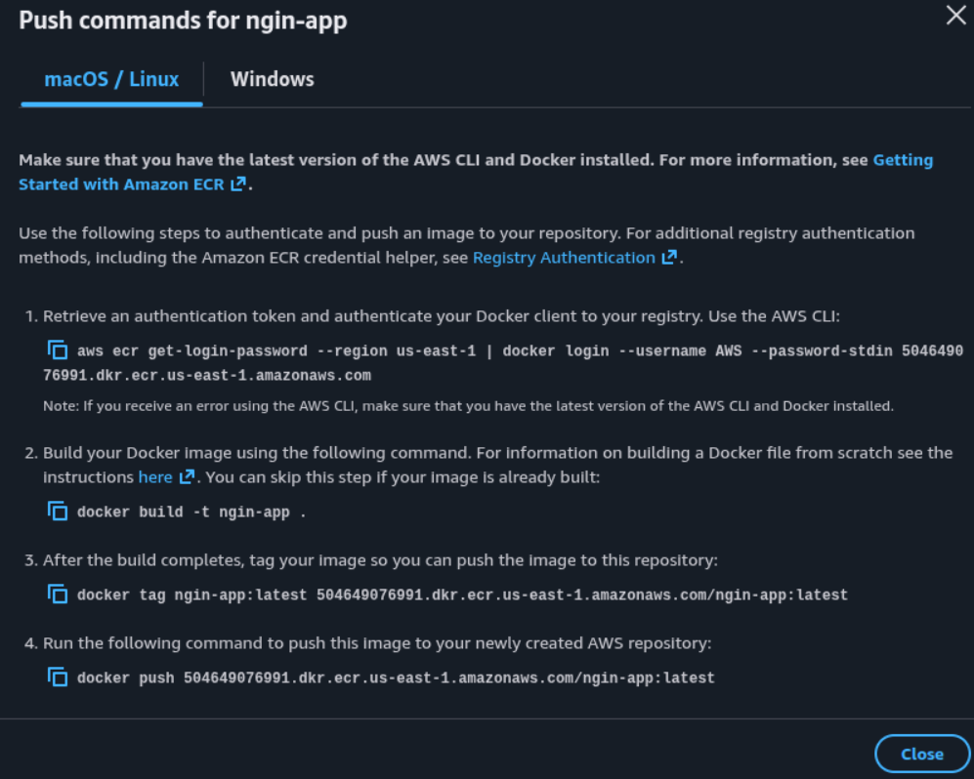
Follow the commands and make sure you put the right directory (where you created your Dockerfile) while building the custom image.

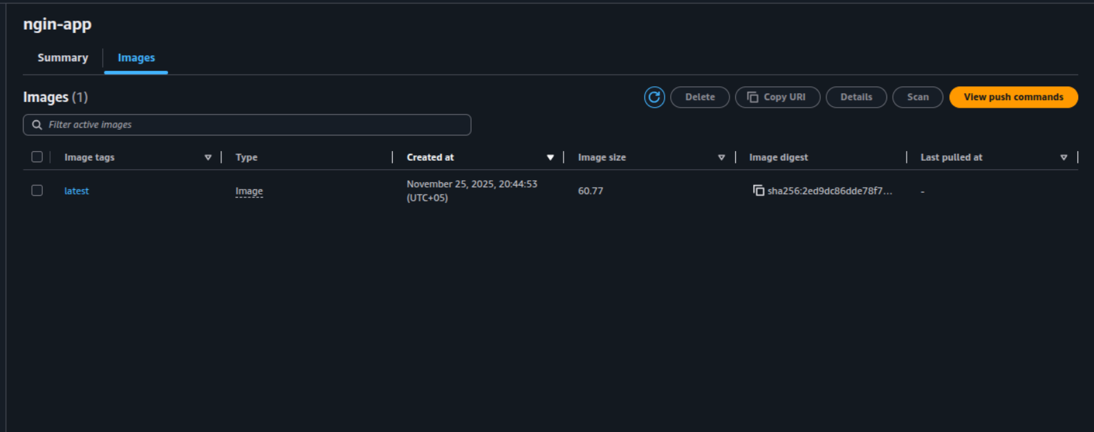
Validation and Testing
Once Terraform resources are deployed and the image is available in ECR, proceed with verifying the deployment.

1. Validate Infrastructure from the AWS Console
Check that the expected infrastructure components exist:
- VPC created with correct CIDR and subnets
- NAT gateway and routing working properly
- Application Load Balancer provisioned and in Active state
- ECS cluster deployed
- Service running one or more tasks
- Task memory and CPU values correctly assigned
- EFS file system and mount targets created
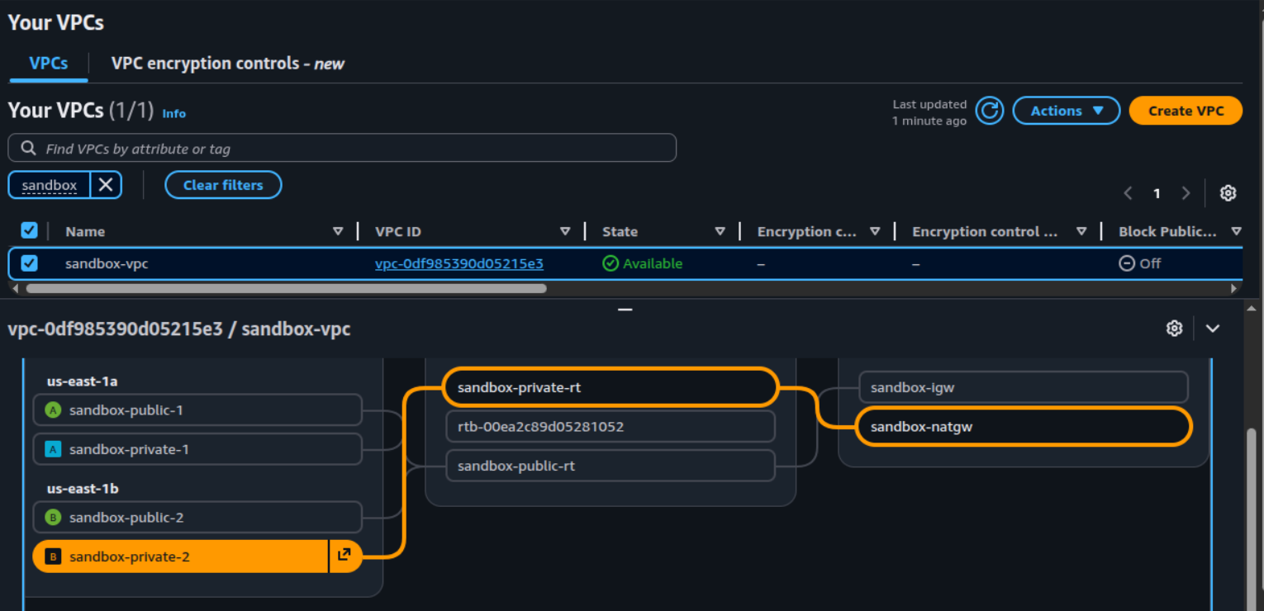
- ECR repository present

2. Validate Application via Browser
Use the ALB DNS name from Terraform outputs:
http://<alb-dns-name>
Expected results:
- NGINX default page loads
- Application loads even after refreshing, confirming containers are healthy
- Stopping a task should trigger Fargate to re-provision one automatically

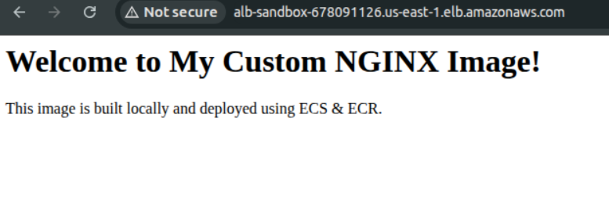

3. Cleanup
To remove all resources:
terraform destroy
Type yes when prompted.

Troubleshooting

Issue 1 : ALB Shows Service Unhealthy
Possible causes:
- Incorrect health check path
- Container not listening on port 80
- Security group not allowing ALB access
Resolution:
- Confirm ALB health check path matches application endpoint (/)
- Ensure task definition containerPort equals 80
- Confirm ALB security group can reach ECS SG

Issue 2: 403 Forbidden Error
Issue:
A 403 Forbidden error from the ALB typically indicates that the NGINX server is running but is not serving the expected content or is misconfigured.
Fix:
- Check File Permissions: Ensure the files in /usr/share/nginx/html (mounted from EFS) have the correct permissions for the NGINX user. Or set the mounPoints inside taskdef.tf as containerPath = “/mnt/efs” where there is no permission issue.
- Check ALB Target Group: Ensure the target group is correctly configured and the ECS tasks are registered as healthy targets.

Issue 3 : Using the same CIDR range as other users
Cause:
If multiple teams or users are creating VPCs in the same AWS account with identical CIDR blocks (e.g., 10.0.0.0/16, 10.0.1.0/24), AWS may allocate overlapping IP ranges between subnets or ENIs. This can lead to routing conflicts, unreachable workloads, or unexpected errors when attaching network interfaces.
Fix:
Assign a unique CIDR range for your VPC and subnets before running terraform apply. For example:
- VPC: 10.44.0.0/16
- Public subnets: 10.44.1.0/24, 10.44.2.0/24
- Private subnets: 10.44.3.0/24, 10.44.4.0/24
Re-run terraform plan and then apply the updated configuration.

Issue 4 : ECS service shows old/incorrect container image (e.g., WordPress instead of custom NGINX)
Cause:
The ECS task definition was not updated with the new custom image URI in ECR. Even if the image was pushed successfully, the ECS service will continue using the image referenced in the latest task definition revision.
Resolution:
- Update the ECS task definition to reference your custom ECR image, for example:
123456789.dkr.ecr.us-west-2.amazonaws.com/nginx:v1
- Register a new task definition revision.
- Deploy the service again so it forces a new deployment using the updated task.
After deployment, the ECS console should show the latest revision with the correct container image.

Conclusion
This project successfully deployed a highly avaiable containerized workload on AWS using ECS Fargate, integrated with an Application Load Balancer and persistent storage via EFS. The workflow begins with Terraform provisioning the VPC, networking, security groups, IAM roles, ECR, EFS, ALB, ECS cluster, and service. Once the infrastructure is created, the custom Docker image is built locally and pushed to ECR. ECS fetches this image at runtime and launches the containers as tasks.
The ALB routes client traffic into the ECS service, performing health checks and distributing load across running tasks. EFS ensures that application data remains persistent even if the tasks redeploy. This architecture enables high availability, isolation, scalability, and maintainability while keeping compute fully serverless through Fargate.
After deployment, updates simply require pushing a new image and triggering a new ECS task definition revision, allowing continuous delivery with minimal downtime.

